Background

Problem

Goals

Success Metrics

Key Features & Scope

Core UX Flow

### Background

Healthcare costs continue to rise at an alarming rate. This has been a major challenge for healthcare providers, patients, as well as, pharmaceutical industries. Kaiser Permanente (KP) wants to explore preventative solutions through technological innovations, an approach that promotes healthy habits, which in return, eliminates chronic disease coupled with reduction in cost of diagnosis and treatment.

### Problem

Chronic disease such as Type-2 Diabetes is affecting quality of lives significantly across age categories. It is a disease that causes damage to large blood vessels of the heart, brain and legs. Also, to small blood vessels, causing problems in the eyes, kidneys, feet and nerves (macrovascular complications). Due to the nature of the disease and how widely spread in the society, the cost of diagnosis and treatment is increasingly high. Healthcare and pharmaceutical industries are faced with uncontrollable costs, projecting 26% increase over a five year period.

The most viable and cost effective preventative approach to reducing and possibly eliminating this staggering cost problem is through controlled healthy habits. This can be achieved with a mobile app that monitors glucose level, tracks and recommend diets, along with appropriate exercise activities. The user gets to have total control of daily diet and exercise habits, which will enhance healthy lifestyle. Healthcare providers can save significantly on costs to diagnose and treat less severe cases.

While the competition’s main focus is on boosting the will power and training human system on habits, the Healthy Living Partner incorporates blood sugar-level monitoring, bundled with Activity Mate and API, thereby providing the user with a wide range of control of key components of a healthy living.

This solution offers a win-win environment for patients, healthcare providers, pharmaceuticals and the society in general. Healthcare can be truly affordable.

### Goals

* Develop and deploy a subscription based mobile app that monitors, tracks,and recommends diet and exercise activities.
* Secure membership subscription of 50,000 in volume within the first 12 months
* Establish incentive programs with health insurance providers through marketing promotion
* Collaborate with KP for tests and progress report

### Success Metrics

* Develop and launch a stable mobile app by the end of the first 6 months at the app store.
* Secure 2000 Trial members for Beta test in 3 months
* Increase subscription to 50,000 within the first 6 months of deployment with increased active user Frequency of use or session length
* Quality - Efficiency(ease of use), Success stories, Feedback, App Store ratings of 4.5 stars

### Key Features & Scope

To create an app that assists people to live a healthy life through monitored and controlled practice, thereby preventing chronic disease.

|  |  |  |  |
| --- | --- | --- | --- |
|  | Goals | Signals | Metrics |
| Happiness | Higher App Store and User rating | Increasing ratings from App Store purchase and User | Rating of 4.0 stars or higher within first 12 months |
| Engagement | Increased app feature usage | Progressively increasing and consistent key feature usage by each user | Daily average number of feature used - 3 minimum  With session Length |
| Adoption | New membership subscription over 12 month period | New user registration | 50,000 membership tracked monthly |
| Retention | Ratio of user staying and dropping out | Stable and increasing membership count with Zero drop-out | Gain/Loss Ratio -  Monthly number of user gained  Monthly number of users lost |
| Task Success | Percentage achievement success | User completes recommended tasks | Minimum percentage success of 75% |

Features

1. Blood sugar-level monitor
2. Diet Assistant
3. Exercise Activity Mate
4. Performance Monitor
5. Application Programming Interface(API)

|  |  |  |
| --- | --- | --- |
| Priority | Feature | Description |
| P0 | User registration | Users provide personal information such as name, address, date of birth, email, password and mobile phone number for membership/subscription registration |
| P1 | Sign-in with email account and password | Users can log into the app using email and password.  A 4 digit code will be sent to the user for additional authentication |
| P2 | Blood sugar-level monitor | Users supply the app with temperature, pulse data etc. and receive the blood sugar level readings. |
| P3 | Diet Assistant | A diet list/menu. Users can choose a diet from a list. Option for a recommended diet for Breakfast, Lunch and Dinner |
| P4 | Exercise Activity Mate | An exercise activity list. Users can choose an exercise from a list. Option for a recommended exercise daily with duration. |
| P5 | Performance monitor | Users can see activity summary data with percentage completion. |

### Core UX Flow

See the link to Healthy Living Partner prototype in Figma

[Prototype Link: Healthy Living Partner](https://www.figma.com/proto/jWkYF0Wsq68aAYEP54olw6/Healthy-Living-Partner-(New)?node-id=7%3A0&viewport=502%2C233%2C0.2484641671180725&scaling=scale-down)

### Target Market

The app is targeted towards adults within 45 to 75 years of age, people with Type_2 Diabetes or similar type of chronic disease, as well as, anyone interested in adopting healthy lifestyle habits.

### Total Addressable Market(TAM)

The estimated Total Addressable Market for this product is (85 Million) x ($4.95) x (12 month per year) =$ 5.049B  
Estimated population of people aged 45 to 75 is about 85 Million (US)  
Subscription price per user is $4.95 per month

Time projection is 12 months

Assumptions

* Initial product release will be for the US market.
* Plan for future expansion to other markets later

[Population Distribution by Age](https://www.kff.org/other/state-indicator/distribution-by-age/?currentTimeframe=0&sortModel=%7B%22colId%22:%22Location%22,%22sort%22:%22asc%22%7D)

[US population Age and Sex composition](https://www.census.gov/prod/cen2010/briefs/c2010br-03.pdf)

### Competition

Momentum Habit Tracker by Apple/Mathias Maehlum

This is an App that boosts willpower and helps you reach goals

Features

* Calendar
* Data Export to CSV
* Reminder
* Interactive Notifications
* Weekly Targets, Notes

Momentum is a subscription based app offered for $3.99/month or $14.99/year.

There is no free reliable data available on specific market penetration for this product as of now. The information provided is based on general market projection only. App is listed among top 10 apps for healthy habits with 4.3 stars ratings. Further investigation into the revenue and number of users is work in progress.

[Best hahit-tracking apps in 2020](https://www.lifehack.org/668261/best-habit-tracking-apps)

Habitbull by Appholdings

This a multi-platform companion app that allows users to form/drop and keeps track of habits and routines.

Features

* Repeated to do's or goals
* Calendar
* Streak counter and percentage successful for each habit
* Inspiring quotes per category

Habitbull basic version is free, allowing users to track up to 5 habits. The premium version subscription is available for $3.99/month or $14.99/year, which allows up to 100 habits.

There is no free specific market penetration data yet. The app is listed among top 10 apps for healthy habits with 4.5/5 ratings. Further investigation into the revenue and number of users is work in progress.

[Best habit-tracking apps in 2020](https://www.lifehack.org/668261/best-habit-tracking-apps)

### Acquisition Channel Strategy

1. Healthcare Providers

Collaboration with Kaiser Permanente, United Healthcare System, Anthem and other healthcare service providers to promote and offer the app (Healthy Living Partner) to patients. This makes the product more compelling to patients and provides a wider reach to clinical patients.

1. App Store SEO

Optimize search level to increase visibility and attract more traffic to the app page in the App Store for drawing potential customers. This puts the product at the forefront of the app store advertisements.

1. Advertising and partnering with Health Insurance service providers

Work with Health Insurance service providers through ads and promotional programs offering discounts to health insurance clients with Healthy Living Partner subscription membership. The opportunity with this strategy lies with cost saving for insurance customers, which is a significantly large community.

### Pricing Strategy

Target Revenue - Subscription registration target for the first 12 months is 50,000 paid members, with a projected revenue of about $2.97 million for the initial release.

Competitive Pricing - The initial strategy for pricing is to go-to-market with competition pricing. Once users get to experience the value and the depth of offering in the product, then a change in price for the future.

### Pre-Launch Checklist

|  |  |
| --- | --- |
| Team | Planned Meeting/Discussion |
| Scrum/Development | * Discuss product development status * Review deliverables and time schedule * Sign-off meeting schedule * Launch date schedule |
| Engineer(IOS/Android) | * Discuss status and progress to date * Any issues or matters of concern * Launch date schedule |
| QA/Test | * Review outstanding/open test issues, if any * Sign-off meeting schedule * Launch date schedule |
| Legal and Compliance | * Review product scope and areas of compliance * Get and discuss feedback * Sign-off meeting schedule |
| Product Marketing | * Review Launch plan * Review supporting material * Sign-off meeting schedule |
| Data Analytics | * Review analytics feedback * User analytics/User data |
| Customer Service | * Supporting documentation and Training material. * Feedback from trials |

### Risks

|  |  |
| --- | --- |
| Risks | Mitigation |
| Open Ticket/Unresolved Issue | Review all outstanding tickets and communicate status using a work management too with the team. |
| Unexpected Software glitch from tests | Have engineering support on call incase of emergency |
| Possibility of security breach | Put engineering and customer support on alert and create awareness of the need to monitor the server. |

### Post-Launch Data

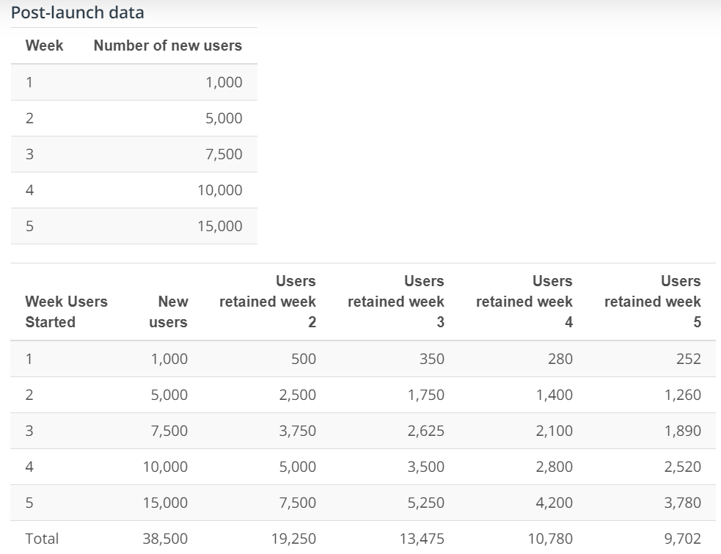

### Field Feedback

Your users are adopting the app, but they are not granting you permissions for notifications (only 10% of all your users granted you notifications permissions. What can you do to improve that?

### Post-Launch Data Review

|  |  |
| --- | --- |
| Feedback issue raised | Proposed solution |
| 1. Users not granting permissions for notifications | Take a two step approach   1. Default setting during download and installation should automatically be set to allow notifications for the apps, with an option to decline. Users should be presented with a message explaining the benefit of allowing notification. 2. Create a reward program that will yield credit for users, which could be applied to a subscription fee. Example, for every notification, a point is awarded. This will serve as motivation for users. |
| 1. Decreasing number of retained users | A user research will be necessary in this situation. The research will give a better insight to why users are not being retained longer and more. The data does not specify enough to make any reasonable judgement as to why. |

### A/B Test for proposed solution

Group A - This group will stay with the ‘A’ version [Control] of the product software and do nothing.

Group B - This group will work with the ‘B’ version [Variant] of the product software, which will be modified to allow notification by default. A message explaining the benefits of the option to be displayed in the process to draw the user's attention. Note - In conjunction with this, the user is awarded points that will be used as credit towards subscription fees.

Success Metric

50% or higher of users in the test group accept Healthy Living Partner notifications

Hypothesis

Our hypothesis is that by setting notification default to ‘Allow’, accompanied by a benefit message will motivate users to continue to allow notifications from this app.